**ADMIN WIREFRAME**

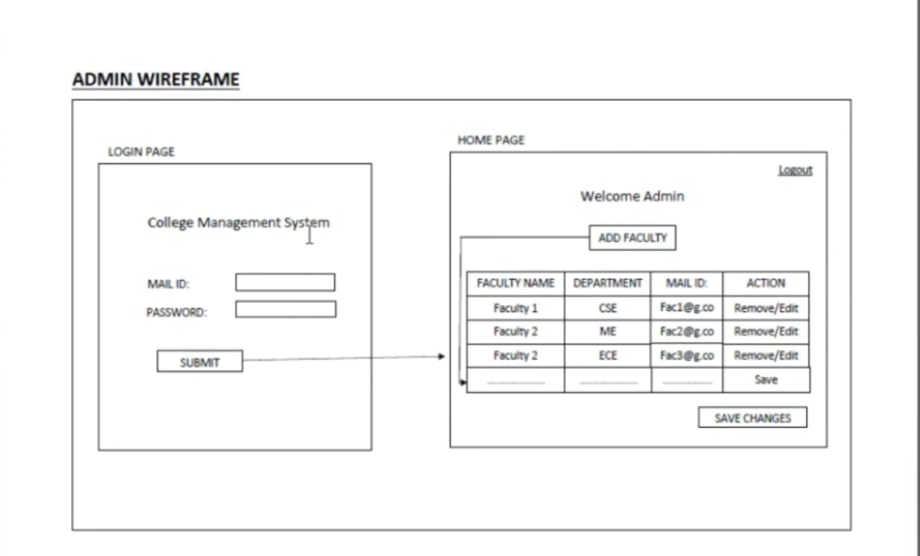

**Working and Functions**

* The admin add faculty to the college by logging in to the college site.
* The admin also modifies the faculties information.

**FACULTY WIREFRAME**

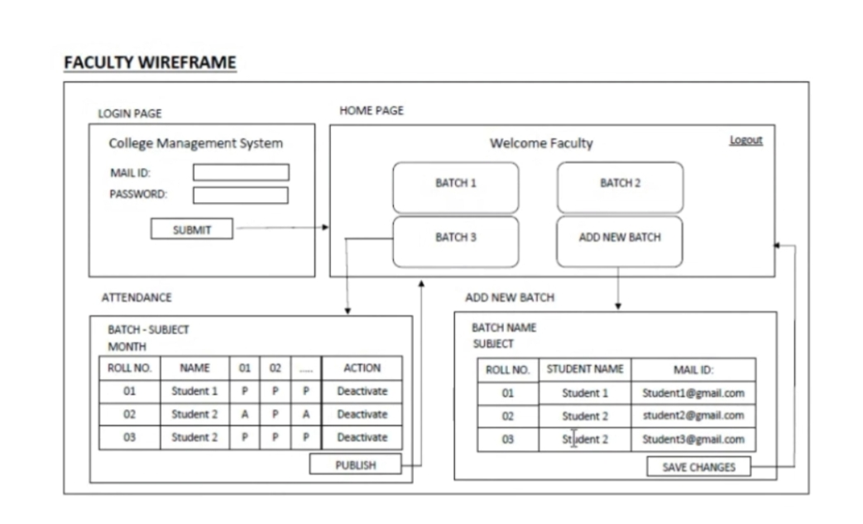

**Working and Functions**

* The faculty adds new batch of students to the class.
* The faculty takes daily attendance of each student.

**STUDENT WIREFRAME**

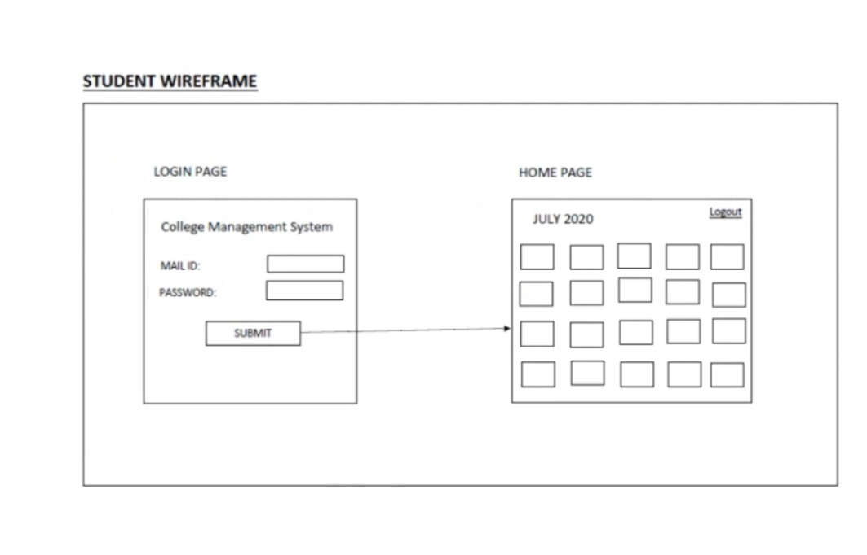

**Working and Functions**

* Student can check the attendance percentage by selecting specific months.
* Student can also check which day, he/she is present.